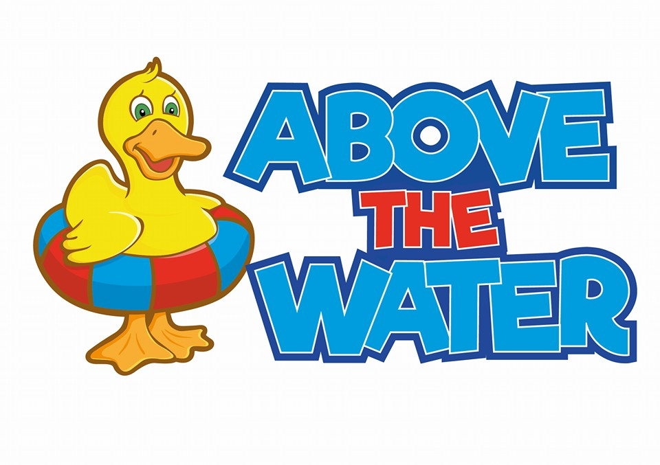

**Equality and Diversity policy**

This policy considers the following existing legislation:

• Equality Act 2010

The Equal Pay Act 1970

• Human Rights Act 1988

• Civil Partnership Act 2004

• Gender Recognition Act 2004

• The Rehabilitation of Offenders Act 1974

• The Equality Act 2010

•The Asylum & Immigration Act 1996.

**Introduction**

Above the Water respects and values equality and diversity. We are strong promoters that that everyone should be treated equally, regardless of their age, race, sex, sexual orientation, pregnancy and maternity, gender reassignment, religion or belied, marriage or civil partnership and disability. Under no circumstances do we tolerate or accept any unfair treatment, harassment, victimisation, and discrimination at Above the Water. We will always treat customers, swimmers, staff and the community with respect, dignity, courtesy, and consideration always.

**Commitment to Equality & Diversity:**

The Equality & Diversity Policy requires commitment from everyone within the Company.

**Your Rights & Responsibilities:**

You can expect to be treated with respect, dignity, courtesy, and consideration always by our staff and we require you to treat our staff in the same way. You will not be discriminated against or treated unfairly in any way on the grounds of your age, race, sex, sexual orientation, pregnancy and maternity, gender reassignment, religion or belied, marriage or civil partnership and disability.

**What does “disability” mean?**

The word “disability” has a wide meaning under the Equality Act. For this document we will be using the Equality Act’s definition: ‘physical or mental impairment which has a substantial and long-term adverse effect on your ability to carry out normal day-to-day activities’.

In terms of disabilities our staff have undergone a lot of training to support different disabilities. We will endeavour to provide the best service possible and make reasonable adjustments for anyone who needs them.

**Our Responsibilities:**

At Above the Water we ensure that we create a workplace where staff are always part of a team and feel valued and respected. Upon commencement of their employment, all members of staff will receive a copy of all policies, so they have a clear understanding of the company’s expectations. We will deliver training on new and revised legislation to all our staff. All staff must be treated with dignity and respect as well as treat others with dignity and respect. Under no circumstances will our staff tolerate threatening or abusive behaviour towards any member of our staff, centre staff, or member of the public. If this is the case, we will act on this immediately.

We will ensure that fair standards of employment practice are in place.

**Employees’ Responsibilities:**

All our employees must adhere to and comply with this Policy and must treat all colleagues and customers with courtesy, dignity, respect, and consideration always. If employees believe that any form of discrimination is taking place within the workplace, we expect them to report this to Abaigh immediately.

**What to do if this is not the case:**

If this policy is not followed this must be reported immediately to Abaigh. Wherever possible, efforts will be made to identify and remove unnecessary or unjustifiable barriers.

Any feedback or complaints that we receive will be dealt with immediately. We appreciate that this can be a difficult subject to raise and individuals may feel uncomfortable or intimidated. Please note that this situation will be treated with compassion and we will act accordingly.

If you have any concerns, please contact:

Abaigh O’Neill (Director of Above the Water) via email:

[abovethewaterswimmingschool@gmail.com](mailto:abovethewaterswimmingschool@gmail.com)

Via mobile: 07470232757