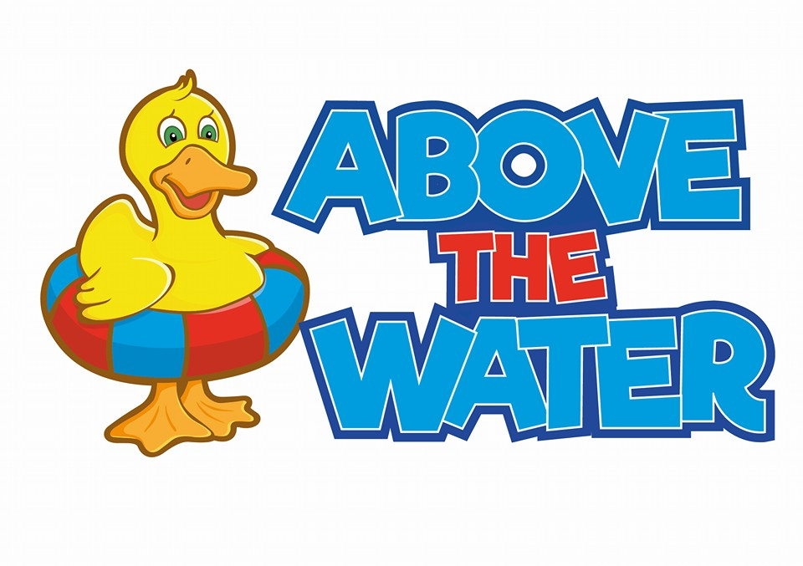

**Privacy policy**

**Privacy Policy**

Above the Water gather and process your personal information in accordance with this policy and in compliance with the relevant data protection Regulation and laws. Here at Above the Water, we are committed to maintaining the trust and confidence of every member at Above the Water. Above the Water takes your privacy seriously and takes every reasonable measure and precaution to protect and secure your personal data. This means we will not sell, rent or trade personal Information with other companies/businesses. We respect and value the privacy of everyone who is part of Above the Water, therefore we will only collect and use personal information in ways that are useful to inform the running of the business. This policy provides you with the necessary information regarding your rights and our obligations, and explains how, why and when we process your personal data.

**Definitions and Interpretations**

In this privacy policy, the following definitions are used:

**“GDPR”** means EU Regulation 2016/679 – the General Data Protection Regulation.

“**Personal information**” means any and all data that relates to an identifiable person who can be directly or indirectly identified from that data. In this case, it means personal data that you give to us via our website by filling out a medical form, from attendance at our classes and information shared between you and staff. This definition shall, where applicable, incorporate the definitions provided in the GDPR.

“**We/Us/Our**” means Above the Water and Above the Water staff.

**What personal information do we collect?**

Above the Water collectspersonal information that is needed to inform our lessons. We also hold contact details in case of an emergency. We hold this information to meet our legal and statutory obligations. We will never collect any unnecessary personal data from you and do not process your information in any way, other than as specified in this notice.

The personal data that we collect from is: -

* Name
* Date of Birth
* Home Address
* Personal Email
* Home Telephone Number
* Mobile Telephone Number
* Health/Medical information

**We collect information through our sign-up form. All information is kept on our software which is password protected.**

We use your medical information to ensure our services are suitable for you. Where we collect such information, we will only request and process the minimum necessary for the specified purpose. The information is key for us to ensure that you are always safe in our environment. This information will only be shared with the Swimming Teacher. We ask you to inform us of anything below which is under the “special category data” conditions as listed in Article 9(2) of the GDPR, when applying to swim with us. This personal information could include:

* Previous and current health and medical issues
* Details of prescribed and non-prescribed medication currently being taken
* Details of any current and/or previous injuries
* Details of any specific dietary requirements

**What we do with the information?**

We require this information to understand your needs and provide you with a better service, and for internal record keeping. We are committed to ensuring that your information is secure. In order to prevent unauthorised access or disclosure, we have put in place suitable physical, electronic and managerial procedures to safeguard and secure the information we collect online.

**Where do we store your personal information?**

Your data is only accessed by the Swim school owner, Abaigh. Occasionally parts of the information are shared if necessary, e.g. medical conditions. All information is password-protected and checked regularly. We are committed to keeping your personal information secure and we have put in place physical, electronic and procedural systems to safeguard the personal information collected through our website and in person at our facilities.

It is important to remember that the transmission of information *via* the internet is not completely secure. Although we will do our best to protect your personal information, we cannot guarantee the security of your personal information transmitted to our Websites; any transmission is at your own risk. We therefore advise you to take suitable precautions when transmitting to Us *via* the internet. It is therefore important to remind you that

you are not obligated to provide your personal information to Above the Water. However, we do ask for this information to ensure we have appropriate precautions in place if needs be.

**Your individual rights**

You have the right to access any personal information that Above the Water holds about you and to request information about:

* What personal data we hold about you
* The purposes of the processing
* The recipients to whom the personal data has/will be disclosed
* How long we intend to store your personal data for
* If we did not collect the data directly from you, information about the source

If you believe that we hold any incomplete or inaccurate data about you, you have the right to ask us to correct and/or complete the information and we will strive to do so as quickly as possible. If you no longer swim with Above the Water, you also have the right to ask us to delete your data.

    Under the GDPR you have the following rights:

* the right to be informed
* the right of access
* the right to rectification
* the right to erasure
* the right to restrict processing
* the right to data portability
* the right to object to the processing of your Personal Information
* rights in relation to automated decision making and profiling

If you wish to exercise any of your rights under the GDPR, or if have any questions relating to our Privacy Policy or our use of your personal information, please contact us.

**How do we use your personal information?**

We will only process your personal information lawfully, fairly and transparently and where at least one of the following conditions, specified under Article 6 of the GDPR, apply;

* you have given us consent to the processing of your personal information for one or more specific purposes
* the processing is necessary for Us to comply with Our legal obligations
* the processing is necessary to protect someone’s life
* the processing is necessary for our legitimate interests or the legitimate interests of a third party, unless there is a valid reason to protect the individual’s personal information which overrides those legitimate interests

**Do we share your personal information?**

Please note, we do not share or disclose any of your personal information without your consent, other than for the purposes specified in this notice or where there is a legal requirement. We are committed to protecting your privacy – we want to earn and maintain your trust, so we take extra precautions to ensure your data is safe. In certain circumstances we may be legally required to share certain personal information held by us, for example, to comply with any legal obligation, or in order to enforce or apply our terms of use and other agreements; or to protect the rights, property, or safety of us, our customers, or others. This includes exchanging information with other companies and organisations for the purposes of fraud protection and credit risk reduction. Under these circumstances, we do not require any further consent from you to share this and We will comply with any legally binding request that is made of Us.

**How long will we store your personal information for?**

Above the Water only ever retains personal information for as long as is necessary to fulfil the purposes we collected it for.

**What happens if our business changes hands?**

We will destroy all documents.