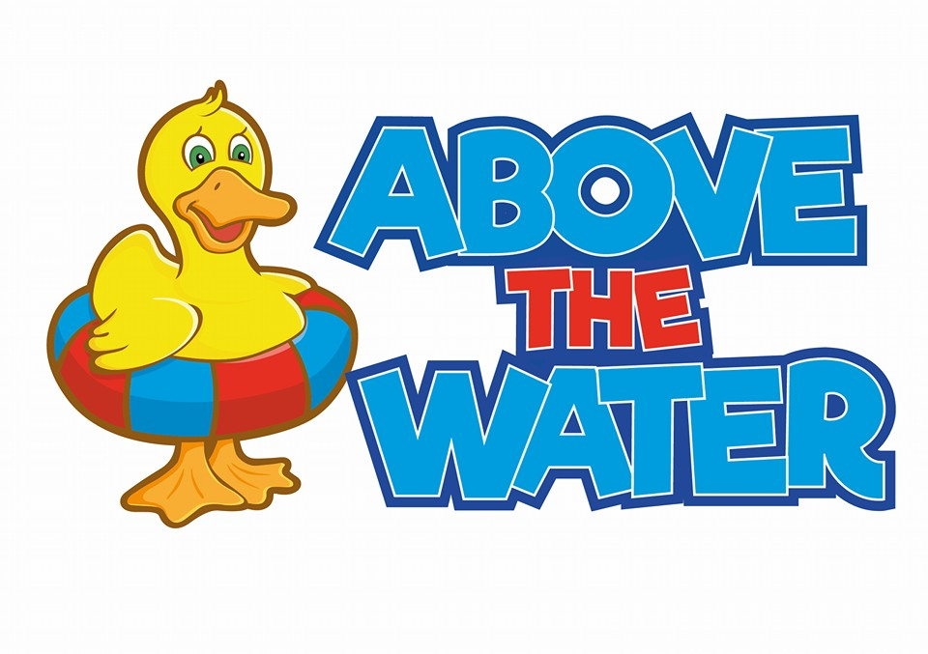

**Photography policy**

**Photography Policy**

It is permitted to record images of your own children taking part in swimming lessons. We understand that they make a lot of progress, learn new things and are having fun! We are happy for you to record your **own** children. However, you must inform a member of staff so we can ensure that no other children are in the film/photo.

Under no circumstance is it ok for you to take a picture/video of another child. Anyone who is seen videoing or taking pictures will be asked to leave unless a member of staff has given permission for this. Please be aware that recording images is **not** permitted under any circumstances in the changing rooms or shower areas.

We ask you to be extremely considerate to this as there are several children who may not be allowed pictures for their own safety. If people do not abide to this policy, we will strictly act by having a ‘NO PHONE POLICY’.

We thank you for understanding.