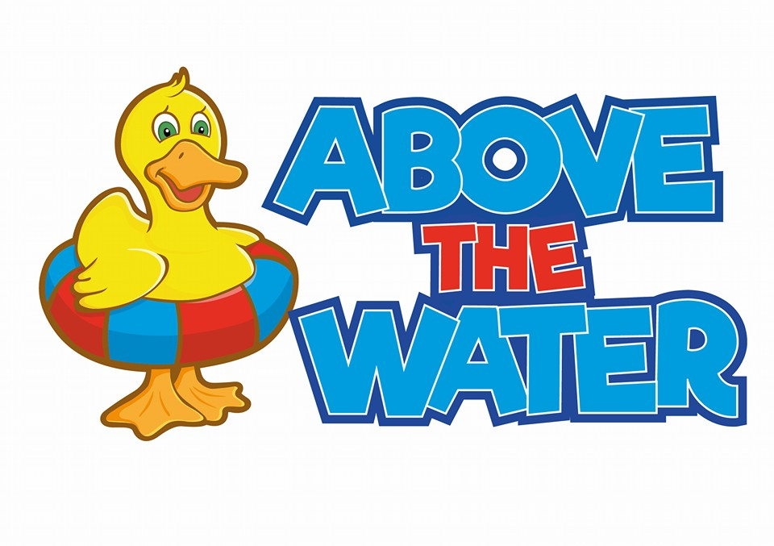

**Safeguarding policy**

**Safeguarding policy**

Above the Water is fully committed to safeguarding. This document highlights both legal and moral obligations towards protecting our swimmers. It recognises the responsibility to promote safe practice and to protect children from harm, abuse and exploitation. For the purposes of this policy and associated procedures a child is recognised as someone under the age of 18 years. Staff will work together to embrace difference and diversity and respect the rights of children and young people. All members of staff have a huge role in terms of Safeguarding. We carry out frequent training around this as well as continue to develop professionally through several online courses. Every staff member before joining Above the Water carries out a Safeguarding course online.

**What is safeguarding?**

Safeguarding is what measures Above the Water takes to protect the health, well-being and human rights of individuals. With a clear focus on Safeguarding we can ensure that the children/swimmers in our care are free from abuse, harm and neglect.

**Principles**

* All children have the right to be protected
* The child’s welfare is paramount
* All suspicions and allegations of abuse will be taken seriously and investigated

**Above the Water will:**

* Always act in the best interest of the child.
* Follow the appropriate steps to ensure everyone is protected.
* Ensure all staff are aware of the signs to look out for.
* Safeguard our children while ensuring that they take part in safe swimming lessons which provide equal opportunities for all.
* Promote and implement appropriate procedures to safeguard the wellbeing of children and protect them from abuse.
* Ensure all staff are up to date with training so everyone can adopt the best practice to safeguard and protect children.
* Respond to any allegations of misconduct or abuse of children in line with this Policy.
* Implement where appropriate the relevant disciplinary and appeals procedures.